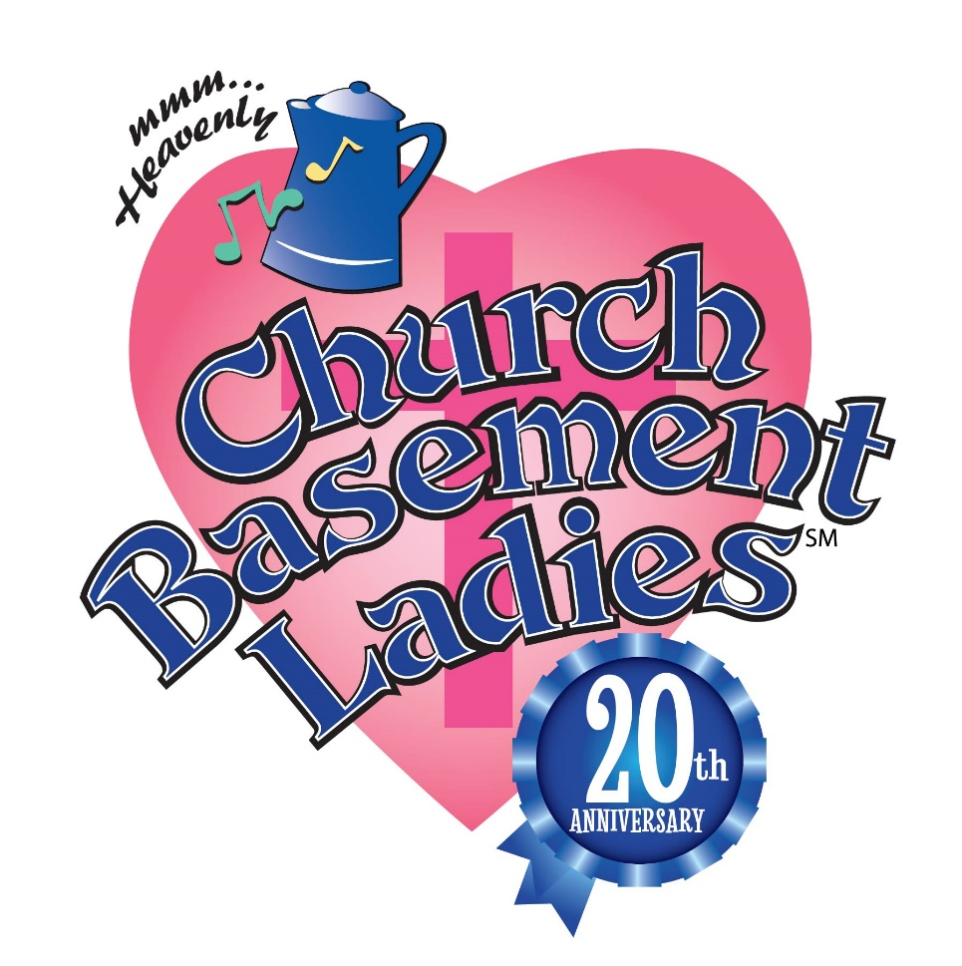

20th Anniversary National Tour for 2022

Church Basement Ladies 20th Anniversary Tour

A musical comedy featuring four distinct characters and their relationships as they organize the food and solve the problems of a rural Minnesota church about to undergo changes in 1965. Funny and down-to-earth, audiences will recognize these ladies as they witness the church year unfold from below the house of God.

